

Java Third Minor Exam

**Objective questions Total Marks: 15**

**Mandatory To attempt all Question**

**Answer is highlight in This Color**

1. **Which of the following is the correct way to increment a variable x by 1 in Java?**
   1. x = x + 1;
   2. x += 1;
   3. ++x;
   4. All of the above
2. **What will be the result of the following expression in Java: 5 + 2 * 3?**
   1. 21
   2. 11
   3. 15
   4. 16
3. **What is the output of the following code snippet?**

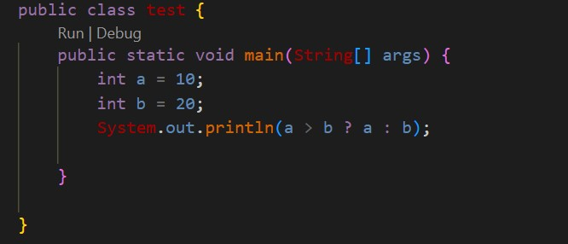

* 1. 10
  2. 20
  3. 30
  4. Compilation error

1. **Which operator has the highest precedence in Java?**
   1. &&
   2. +
   3. *
   4. ++
2. **What is the output of the following code snippet?**

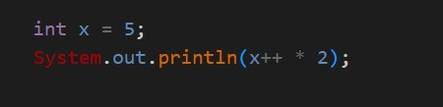

* 1. 10
  2. 12
  3. 11
  4. 14

1. **Which of the following is a valid syntax for an if statement in Java?**

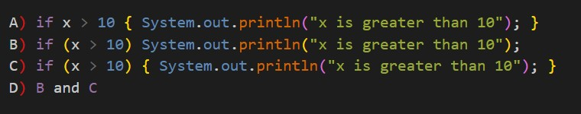

**Answer= B and C**

1. **What will be the output of the following code snippet?**

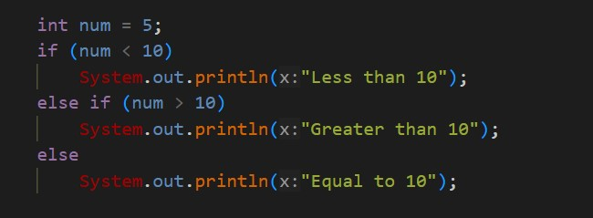

* 1. Less than 10
  2. Greater than 10
  3. Equal to 10
  4. Compilation error

1. **What is the output of the following code snippet?**

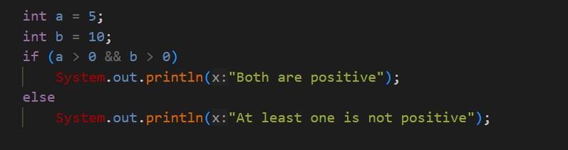

* 1. Both are positive
  2. At least one is not positive
  3. No output
  4. Compilation error

1. **Which statement is used to terminate the execution of a loop or switch statement in Java?**
   1. continue
   2. break
   3. return
   4. exit
2. **What will be the output of the following code snippet?**

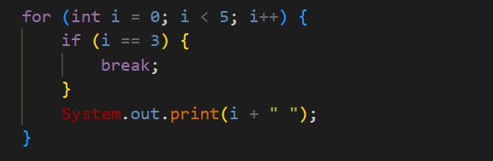

* 1. 0 1 2 3 4
  2. 0 1 2
  3. 0 1 2 3
  4. 0 1

1. **What is the role of the continue statement in a loop in Java?**
   1. To terminate the loop
   2. To skip the current iteration and continue with the next iteration
   3. To break out of the current block
   4. None of the above
2. **What will be the output of the following code snippet?**

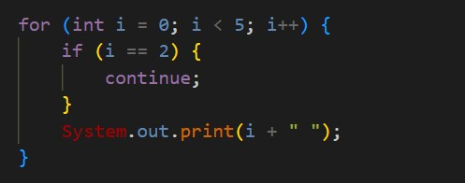

* 1. 0 1 2 3 4
  2. 0 1 3 4
  3. 0 1 4
  4. 0 1 2

1. **What is the output of the following code snippet?**

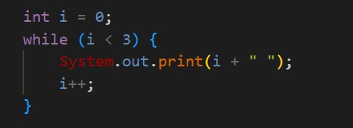

* 1. 0 1 2
  2. 1 2 3
  3. 0 1 2 3
  4. Infinite loop

1. **Which loop is guaranteed to execute at least once in Java?**
   1. for loop
   2. while loop
   3. do-while loop
   4. None of the above
2. **What will be the output of the following code snippet?**

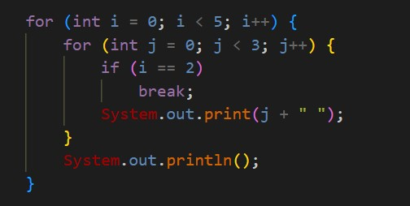

1. 0 1 2 0 1 2 0 1 2 0 1 2 0 1 2
2. 0 1 2 0 1 2 0 1 2
3. 0 1 0 1 0 1 0 1 0 1
4. 0 1 0 1 0 1 0 1 0 1 0 1

Answer= 0 1 2 0 1 2 0 1 2 0 1 2

"जो अपने सपन का पीछा करते ह, वह अपनी क मत खदु बनाते ह।"

(Those who chase their dreams create their own destiny.)

Best Of Luck